How to Install Pre-Approved Software via Company Portal

Purpose:
The purpose of this article is to guide users on how to install pre-approved company software.
Target Audience:
All Windows 10 or 11 laptop/desktop computer users.

Examples of when to use this article:
- User receives email from Adobe indicating license has been assigned, but needs to install Acrobat Pro.
- Chrome Browser was uninstalled from your computer.
- A Microsoft Project license has been assigned to you, but the program needs to be installed.

Instructions:
Step 1: Click on the search icon on the bottom left-hand side of your taskbar next to the Windows button.
Step 2: Type “Company Portal” and press enter.
Note: It may or may not prompt you to sign in. If it does, please enter your email address and Okta password.
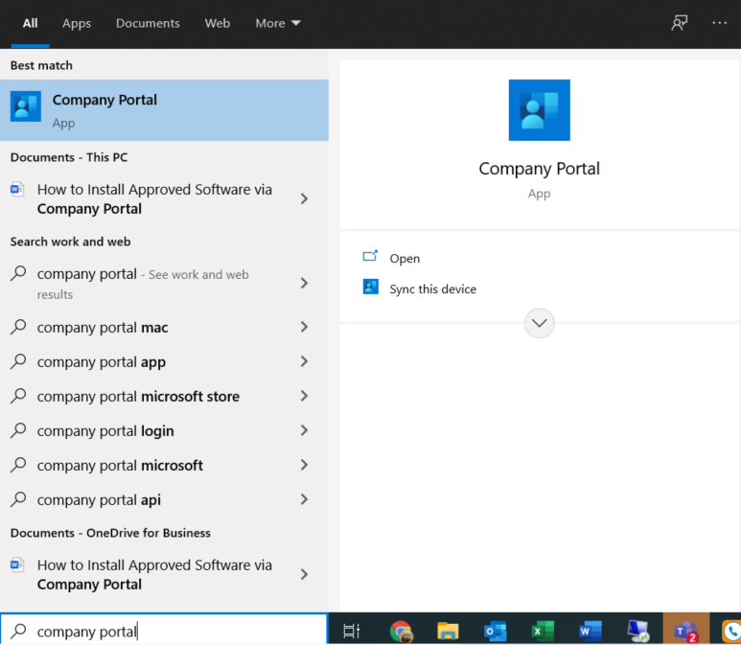
Step 3: Find the application you wish to install, right-click it and click “Install”. (It will go through “download pending”, “downloading” and then “Installed.”)
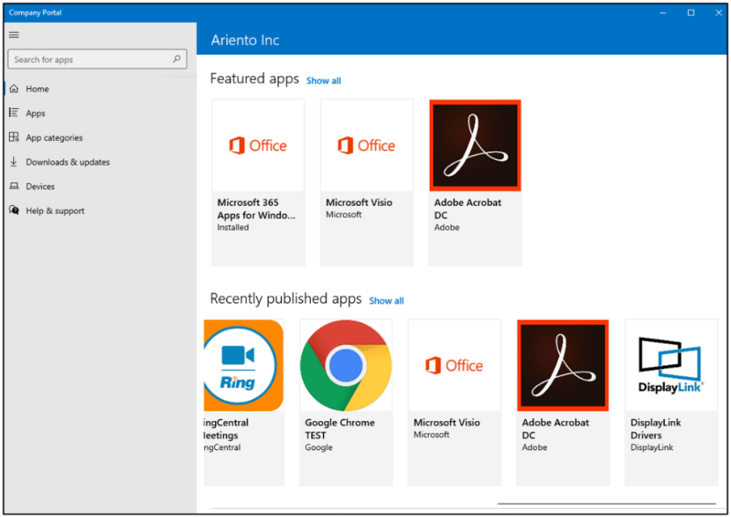
Note: If you do not see the desired application or if the install fails, please contact support at ariento.com/support for assistance.

Relevant Articles/References (Links):
- None

