How to Add an Office Printer

Purpose:
Provide instructions for how a user can add an office printer to their computer so they can print from it.
Target Audience:
Users that need to connect to an office printer.

Examples of when to use this article:
- I’m in an office and need to connect to the printer.

Before We Start:
- Computer must be in the office where the printer is located.

Instructions:
Step 1: Go to your system tray located in the Window’s Taskbar, usually at the bottom right corner of your desktop, and click on the PrinterLogic icon to add office printer(s).
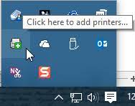

- Step 2: The “Add Printer” option opens the PrinterLogic Self-service Portal, which is a browser-based tool that enables users to easily connect to an office printer. If you don’t see the printer you want to add, please submit a ticket via ariento.com/support .

Step 3: If this is your first time accessing the PrinterLogic Self-service Portal, you will be prompted to install a Chrome Extension.
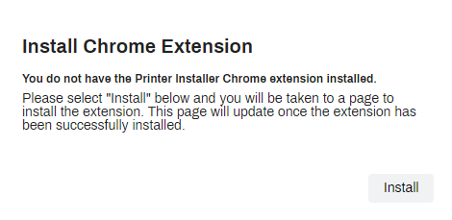
Note – If you run into any issues with installing the Chrome Extension direct link provided within the PrinterLogice Self-service Portal, you may choose the link below to complete the install of Chrome Extension.
https://chrome.google.com/webstore/detail/printerlogic-extension-v1/bfgjjammlemhdcocpejaompfoojnjjfn
Step 4: Pop-up for Chrome Web Store will open for the you to install the PrinterLogic Extension. Please click “Add to Chrome”.
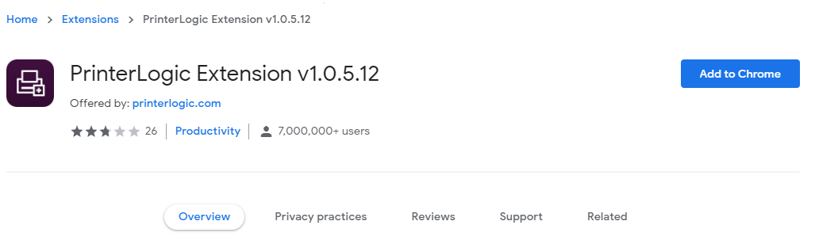
Step 5: Once a pop-up is provided you will need to accept the “Add Extension”.
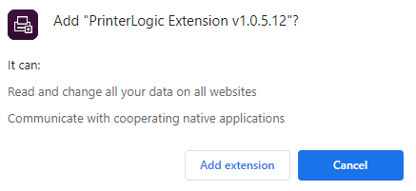

Step 6: After installing the Chrome Extension, go back to the PrinterLogic icon and click on the specific printer you like to connect to and download.
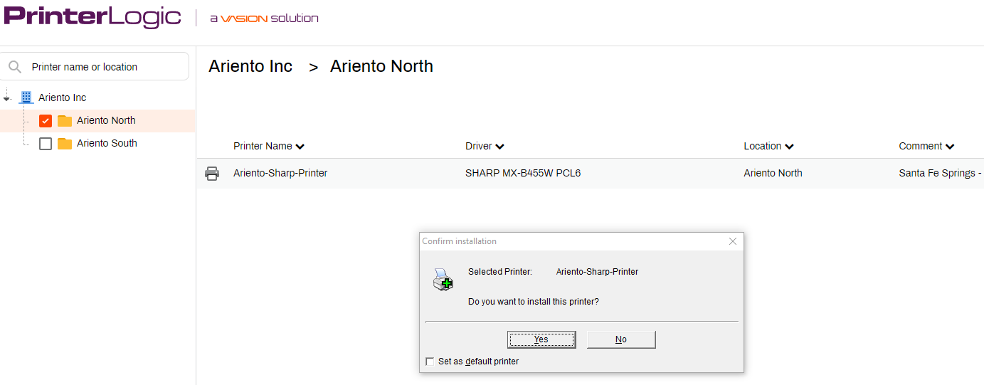

Step 7: Installer bar will appear.
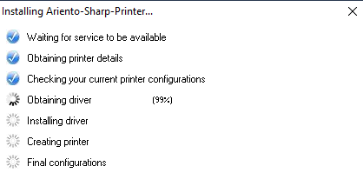
Step 8: Lastly, the “Notice box” will pop-up with printer completion.
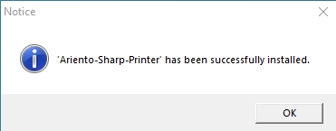

Step 9: Printer will now show up as an option when you are printing. You may need to exit the application you were using first if it doesn’t show up immediately.

Relevant Articles/References (Links):
- None

